Defining simple generic classes
public class Pair<T>
{
private T first;
private T second;
public Pair() { first = null; second = null; }
public Pair(T first, T second) { this.first = first; this.second = second; }
public T getFirst() { return first; }
public T getSecond() { return second; }
public void setFirst(T newValue) { first = newValue; }
public void setSecond(T newValue) { second = newValue; }
}
- The Pair class introduces a type variable T, enclosed in angle brackets < >, after the class name.
- A generic class can have more than one type variable.
Generic Methods
- private static <T> String Shout(<T> name)
Bounds for Type Variables
- How do we know that the class to which T belongs has a compareTo method?
- The solution is to restrict T to a class that implements the Comparable interface a standard interface with a single method, compareTo.
- You can achieve this by giving a bound for the type variable T
- public static <T extends Comparable> T min(T[] a) ...
Generic Code and the Virtual Machine
Type Erasure
- Whenever you define a generic type, a corresponding raw type is automatically provided.
- For example, the raw type for Pair<T> looks like this:
public class Pair
{
private Object first;
private Object second;
public Pair(Object first, Object second)
{
this.first = first;
this.second = second;
}
public Object getFirst() { return first; }
public Object getSecond() { return second; }
public void setFirst(Object newValue) { first = newValue; }
public void setSecond(Object newValue) { second = newValue; }
}
Translating Generic Expressions
Translating Generic Methods
Calling Legacy Code
- When Java generics were designed, a major goal was to allow interoperability between generics and legacy code.
Restrictions and limitations
- Type Parameters Cannot Be Instantiated with Primitive Types
- You cannot substitute a primitive type for a type parameter. Thus, there is no Pair<double>, only Pair<Double>.
- Runtime Type Inquiry Only Works with Raw Types
- if (a instanceof Pair<String>) // ERROR
- You Cannot Create Arrays of Parameterized Types
- var table = new Pair<String>[10]; // ERROR
- Varargs Warning
- You Cannot Instantiate Type Variables
- public Pair() { first = new T(); second = new T(); } // ERROR

- You Cannot Construct a Generic Array
- T[] mm = new T[2]; // ERROR
- Type Variables Are Not Valid in Static Contexts of Generic Classes
- private static T singleInstance; // ERROR
- You Cannot Throw or Catch Instances of a Generic Class
- You Can Defeat Checked Exception Checking
@SuppressWarnings('unchecked')
static <T extends Throwable> void throwAs(Throwable t) throws T
{
throw (T) t;
}
- Beware of Clashes after Erasure
Inheritance Rules for Generic Types
- Is Pair<Manager> a subtype of Pair<Employee>? Perhaps surprisingly, the answer is “no.”
- Pair<Employee> buddies = new Pair<Manager>(ceo, cfo); // illegal
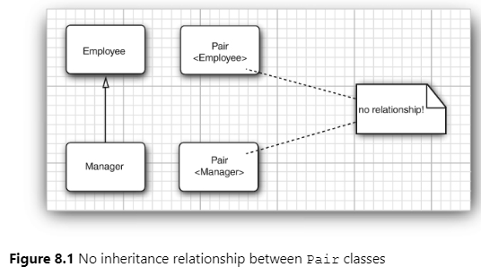
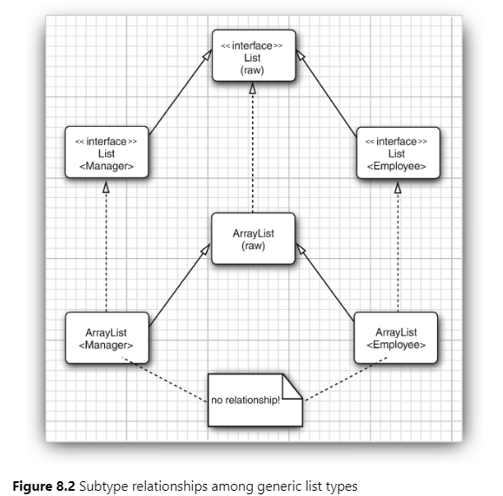
Wildcard Types
- In a wildcard type, a type parameter is allowed to vary. For example, the wildcard type
- Pair<? extends Employee>
- denotes any generic Pair type whose type parameter is a subclass of Employee, such as Pair<Manager>, but not Pair<String>.
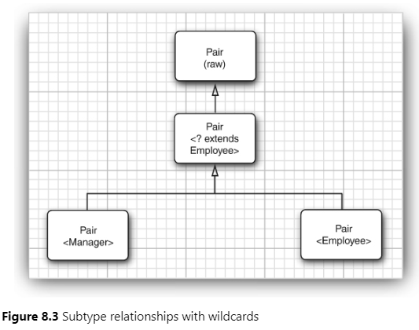
Supertype Bounds for Wildcards
- ? super Manager
- This wildcard is restricted to all supertypes of Manager.
- Intuitively speaking, wildcards with supertype bounds let you write to a generic object, while wildcards with subtype bounds let you read from a generic object.
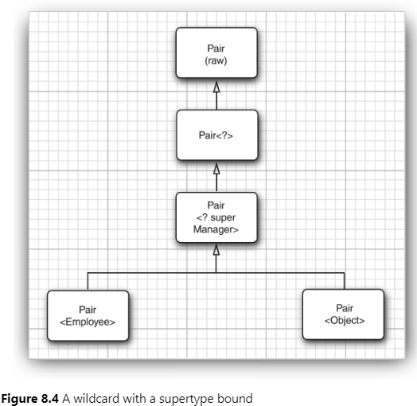
Unbouded Wildcards
Wildcard Capture
Reflection and Generics
Using Class<T> Parameters for Type Matching
Generic Type Information in the Virtual Machine
Type Literals

